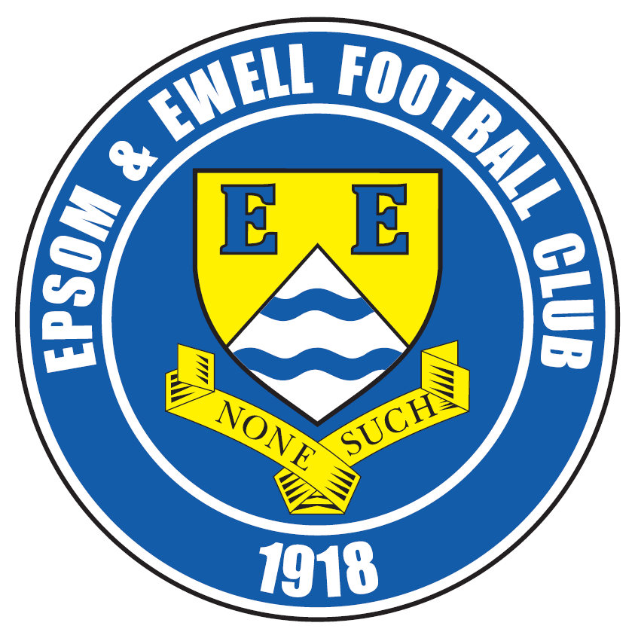 | Epsom & Ewell F.C.  15  v  Sutton Common Rovers  Saturday, 19th December 2015 – 3.00pm

Good afternoon! We welcome the players, supporters and officials of Sutton Common Rovers Football Club, together with today’s match officials and our own regular supporters.

We are nearly at Christmas and many Managers say that they don’t look at the League table until then. Apart from that being an obvious lie, I’ve thoroughly enjoyed looking at the table so far! We currently have just the one League defeat, something we haven’t achieved since 1974/75 and it’s always good when we can compare ourselves with that phenomenal season! Obviously as any Manager would also tell you, the job is nowhere near done yet and the hard work continues today.

Today’s opponents had a slow start to the season but have picked up well and also remain in the F.A. Vase where they came from two goals behind to defeat Eastbourne Town last weekend. As Eastbourne are second in their League they certainly won’t fear a trip here and we can be assured of a competitive battle today. We know they have been drawn against either FC Broxbourne Borough or Bowers & Pitsea away in the next round and we wish them luck in that tie.

We were due to be on the field eleven days ago but had to postpone at short notice due to Cove’s inability to raise a team. These are dark days at Cove and they have been given a couple of weeks off by the League. Whilst any recovery will surely come too late for this season we hope to see them again soon. We apologise to any supporters that made the fruitless journey here, although the information was on both our Twitter feed and our Facebook page, so please join up if you can.

We then won 1-0 at Badshot Lea on Saturday thanks to a brilliant free kick from Matt Ferdinando. Despite their league position the Baggies have produced some good results recently so this was an excellent result. We only have one match over the Christmas period when we travel to Horley Town for a Monday morning kick off on December 28th. We are then back here to meet Redhill on Saturday 2nd January, so please put those dates in your diaries.

On the field we have a few new faces, although all will be familiar to regular supporters. Carl Downs has played recently, while Agi Panayiotou and also former Captain Jamie Hatfield have also returned. This is just as well right now as we have a few injuries too. Hopefully James Taylor and Sam Currie will be back soon and then Glyn and Matt can have a proper selection headache!

Enjoy the game!

Rich

You can now follow us on Facebook www.facebook.com/epsomandewellfc or Twitter @EEFCOfficial

Cover Photos v Guildford City 05/12/2015 by Gemma Jarman

- Tom Neale scores our opening goal in the 8th minute
- Kyle Hough volleys in our third goal from Reisse Griffin’s cross


Cherry Red Records Combined Counties League
Premier Division Table 2015/16
inc Tuesday 15th December | P | W | D | L | F | A | Pts | GD | H | A
Hartley Wintney | 19 | 16 | 2 | 1 | 63 | 18 | 50 | +45 | 30/1 | 3-3
Ashford Town (Mx) | 20 | 15 | 1 | 4 | 48 | 25 | 46 | +23 | 30/4 | 3-2
Epsom & Ewell | 20 | 13 | 6 | 1 | 49 | 17 | 45 | +32 | X | X
Camberley Town | 17 | 12 | 3 | 2 | 33 | 14 | 39 | +19 | 16/4 | 20/2
Hanworth Villa | 20 | 11 | 2 | 7 | 39 | 31 | 35 | +8 | 5-0 | 23/4
Horley Town | 18 | 10 | 3 | 5 | 45 | 25 | 33 | +20 | 27/2 | 28/12
Windsor | 20 | 8 | 7 | 5 | 39 | 38 | 31 | +1 | 2-2 | 23/1
Colliers Wood United | 23 | 9 | 2 | 12 | 46 | 41 | 29 | +5 | 3-1 | 3-0
AFC Hayes | 21 | 8 | 4 | 9 | 33 | 34 | 28 | -1 | 1-1 | 9/1
Spelthorne Sports | 20 | 8 | 4 | 8 | 36 | 40 | 28 | -4 | 16/1 | 6-2
Knaphill | 17 | 8 | 2 | 7 | 30 | 21 | 26 | +9 | 12/3 | 1-1
Raynes Park Vale | 21 | 8 | 2 | 11 | 41 | 44 | 26 | -3 | 3-1 | 28/3
Sutton Common Rovers | 21 | 7 | 3 | 11 | 38 | 43 | 24 | -5 | 19/12 | 2-1
Westfield | 17 | 6 | 6 | 5 | 23 | 24 | 24 | -3 | 26/3 | 0-0
Chessington & Hook | 21 | 7 | 2 | 12 | 38 | 49 | 23 | -11 | 1-0 | 19/3
Guildford City | 21 | 7 | 2 | 12 | 40 | 53 | 23 | -13 | 4-0 | 2/4
Badshot Lea | 20 | 7 | 1 | 12 | 25 | 50 | 22 | -25 | 9/4 | 1-0
Farnham Town | 19 | 6 | 3 | 10 | 30 | 32 | 21 | -2 | 1-0 | 6/2
Chertsey Town | 20 | 5 | 5 | 10 | 20 | 31 | 20 | -11 | 0-1 | 5/3
Bedfont Sports | 19 | 4 | 7 | 8 | 26 | 29 | 19 | -3 | 13/2 | 2-2
Redhill | 17 | 3 | 3 | 11 | 23 | 40 | 12 | -17 | 2/1 | 1-0
Cove | 17 | 1 | 0 | 16 | 9 | 73 | 3 | -64 | tba | 7-0

Lucky Day? – 19th December
Played 11 - W 3 D 1 L 7 - F 24 A 24 - PPG 0.91 - Poor
Our Club record against Sutton Common Rovers (inc MVSCR)
Played 9 - W 7 D 1 L 1 - F 24 A 11 - PPG 2.44 - Fantastic
Largest wins and losses against our opponent
30th November 2013 - (H) W 4-0 - League - 28th April 2011 - (A) L 1-4 - League
Last visit
Tuesday 7th October 2014 - W 1-0 - Combined Counties League

Club Manager - Glyn Mandeville
Good afternoon everyone and welcome to today’s game. Also, welcome back to Tony and the staff of Sutton Common Rovers F.C.

We face tough opposition today who have found a bit of form of late in the League and F.A. Vase.


We have been on a great run ourselves and hope to keep it going. In our last game we beat Badshot Lea 1-0 with a great free kick scored by Ferdy. The lads put in a great workmanlike performance and on a pitch not fit enough for cows got the three points we needed away from home.

We welcome back Jimmy our Phyiso who was greatly missed last week and the lads that are injured are on their way back too. This is great for the team but is giving me a very big headache having to pick from a great bunch of lads!

Hope you enjoy today’s game and have a safe trip home.

Manders

Club Captain - Sam Currie

Good afternoon and welcome to High Road for our last game before Christmas.

We will be looking to go into the small break on the back of another well earned three points today. Having played Mole Valley at the start of the season we are aware this will not be an easy task after being taken all the way in the away game with Big Mike having to pull off a penalty save to make sure we gained all three points.

However the last few games have seen us play consistently well and having been out injured I have been pleasantly surprised with the quality and level of performances that we have managed to produce over the last five games, the last one being at Badshot Lea on a pudding of a pitch in which we came up against a physical side- but the clean sheet and a superb strike by “Ferdy” from the first half free kick was enough to get the full quota of points on offer.

We know consistency is key and we will be looking to improve the points tally today but know we have to start on the front foot and take chances when they become available.

We hope you’re in for a good game today against two good sides and wish Mole Valley players, coaching staff and fans a safe journey home following the game.

We thank you for all your support over the year and particularly here at High Road, if you fancy more festive football fun we welcome you to Horley in between Christmas and the New Year, but for now on behalf of the team - we wish you all a Happy Christmas and look forward to seeing you here again in the New Year.

Sam

Latest Results and Fixtures
Combined Counties League – Saturday 5th December
Ashford Town (Mx) | 3-3 | Horley Town
Bedfont Sports | 0-1 | Badshot Lea
Camberley Town | 3-0 | Chertsey Town
Chessington & Hook United | 2-4 | Spelthorne Sports
Epsom & Ewell | 4-0 | Guildford City
Farnham Town | 1-2 | Colliers Wood United
Hanworth Villa | 2-2 | Westfield
Hartley Wintney | 1-0 | Windsor
Knaphill | 3-2 | Raynes Park Vale
Redhill | 0-0 | AFC Hayes
Sutton Common Rovers | 8-1 | Cove
Combined Counties League – Monday 7th December
Sutton Common Rovers | 1-2 | Hanworth Villa
Combined Counties League – Tuesday 8th December
Bedfont Sports | 3-2 | Chessington & Hook United
Windsor | 3-2 | Horley Town
Combined Counties League – Wednesday 9th December
Colliers Wood United | 1-1 | Raynes Park Vale
F.A. Vase Third Round – Saturday 12th December
Ascot United | 0-0+ | Camberley Town
Canterbury City | 1-3 | Knaphill
Colliers Wood United | 1-3 | Hartley Wintney
Eastbourne Town | 2-3 | Sutton Common Rovers
Combined Counties League – Saturday 12th December
AFC Hayes | 4-1 | Chessington & Hook United
Badshot Lea | 0-1 | Epsom & Ewell
Chertsey Town | 4-1 | Farnham Town
Guildford City | 1-3 | Ashford Town (Mx)
Raynes Park Vale | 1-1 | Spelthorne Sports
F.A. Vase Third Round Replay – Tuesday 15th December
Camberley Town | 4-1 | Ascot United
Combined Counties League – Tuesday 15th December
Windsor | 4-1 | Sutton Common Rovers
Combined Counties League Cup Third Round – Tuesday 15th December
Cobham | p-p | Frimley Green
Hartley Wintney | p-p | Chessington & Hook United
Knaphill | p-p | Chertsey Town
Latest Results and Fixtures
Combined Counties League Cup Third Round – Tuesday 15th December
Raynes Park Vale | p-p | Westfield
Redhill | p-p | Farnham Town
Combined Counties League Cup Third Round – Wednesday 16th December
Colliers Wood United | 6-0 | Dorking Wanderers Reserves
Combined Counties League – Saturday 19th December
AFC Hayes | V | Ashford Town (Mx)
Badshot Lea | V | Farnham Town
Bedfont Sports | V | Camberley Town
Colliers Wood United | V | Knaphill
Epsom & Ewell | V | Sutton Common Rovers
Guildford City | V | Chertsey Town
Hartley Wintney | V | Hanworth Villa
Raynes Park Vale | V | Horley Town
Redhill | V | Chessington & Hook United
Windsor | V | Spelthorne Sports
Combined Counties League – Tuesday 22nd December
Sutton Common Rovers | V | Redhill
Combined Counties League – Monday 28th December (check k.o. times)
Ashford Town (Mx) | V | Windsor
Camberley Town | V | Hartley Wintney
Chertsey Town | V | Colliers Wood United
Farnham Town | V | Guildford City
Hanworth Villa | V | Bedfont Sports
Horley Town | 11.30 | Epsom & Ewell
Knaphill | V | Westfield
Raynes Park Vale | V | Chessington & Hook United
Spelthorne Sports | V | AFC Hayes
Combined Counties League – Saturday 2nd January
Ashford Town (Mx) | V | Knaphill
Badshot Lea | V | Westfield
Bedfont Sports | V | Windsor
Camberley Town | V | Chessington & Hook United
Cove | V | Spelthorne Sports
Epsom & Ewell | V | Redhill
Hanworth Villa | V | Guildford City
Hartley Wintney | V | Farnham Town
Horley Town | V | Chertsey Town
Sutton Common Rovers | V | AFC Hayes

First Eleven Appearances - (max 24 – including Badshot Lea – 12/12/15)
Name | Debut | 2014/15 |  |  |  | Career Totals
Name | Debut | App | Sub | Total | Goals | App | Sub | Total | Goals
AJAYI Tayo | 22/08/2015 | 0 | 2 | 2 | 0 | 0 | 2 | 2 | 0
COOPER-SMITH Daryl | 03/01/2015 | 15 | 4 | 19 | 8 | 24 | 7 | 31 | 14
CURRIE Sam | 04/08/2012 | 16 | 1 | 17 | 1 | 124 | 10 | 134 | 3
DAVISON Conor* | 22/08/2015 | 1 | 2 | 3 | 0 | 1 | 2 | 3 | 0
DEAN Dan | 02/08/2014 | 15 | 2 | 17 | 0 | 51 | 3 | 54 | 0
DOWNS Carl | 17/09/2011 | 2 | 1 | 3 | 0 | 96 | 14 | 110 | 2
EACOTT Michael | 02/08/2014 | 21 | 0 | 21 | 0 | 67 | 0 | 67 | 0
FARRELL Matt | 02/08/2014 | 23 | 0 | 23 | 5 | 64 | 3 | 67 | 12
FERDINANDO Matt | 20/09/2014 | 17 | 0 | 17 | 5 | 44 | 4 | 48 | 11
GRIFFIN Reisse | 08/08/2015 | 9 | 4 | 13 | 0 | 9 | 4 | 13 | 0
HASTINGS Craig | 08/08/2015 | 17 | 3 | 20 | 0 | 17 | 3 | 20 | 0
HENDRY Rob | 08/08/2015 | 20 | 3 | 23 | 8 | 20 | 3 | 23 | 8
HOUGH Kyle | 14/08/2007 | 18 | 2 | 20 | 15 | 314 | 17 | 331 | 186
JONES Adrian | 06/08/2011 | 2 | 0 | 2 | 0 | 22 | 0 | 22 | 0
KURDZIEL Jakub | 29/08/2015 | 1 | 0 | 1 | 0 | 1 | 0 | 1 | 0
MARVELL Dale* | 15/01/2000 | 8 | 4 | 12 | 1 | 269 | 49 | 318 | 86
MCGREGOR Alex | 08/08/2009 | 7 | 2 | 9 | 2 | 179 | 58 | 237 | 29
MCKAY Alex | 20/12/2008 | 15 | 1 | 16 | 0 | 100 | 27 | 127 | 8
NEALE Thomas | 13/10/2015 | 5 | 7 | 12 | 3 | 5 | 7 | 12 | 3
NEILL David* | 03/10/2015 | 1 | 1 | 2 | 0 | 1 | 1 | 2 | 0
NORTH Rhys | 16/08/2015 | 7 | 6 | 13 | 0 | 7 | 6 | 13 | 0
OLIVER Beckett | 29/08/2015 | 5 | 9 | 14 | 0 | 5 | 9 | 14 | 0
PANAYIOTOU Savvas | 03/01/2015 | 2 | 0 | 2 | 0 | 18 | 3 | 21 | 3
ROWE Steve | 27/08/2011 | 0 | 1 | 1 | 0 | 24 | 3 | 27 | 0
SMITH Matt | 08/08/2009 | 0 | 0 | 0 | 0 | 91 | 43 | 134 | 10
TANTON Matt | 02/08/2014 | 20 | 0 | 20 | 0 | 38 | 4 | 42 | 1
TAYLOR James | 26/08/2013 | 17 | 2 | 19 | 2 | 73 | 10 | 83 | 5
Own Goal |  |  |  |  |  |  |  |  | 1
* Player has left the club

EL Records Premier Challenge Cup
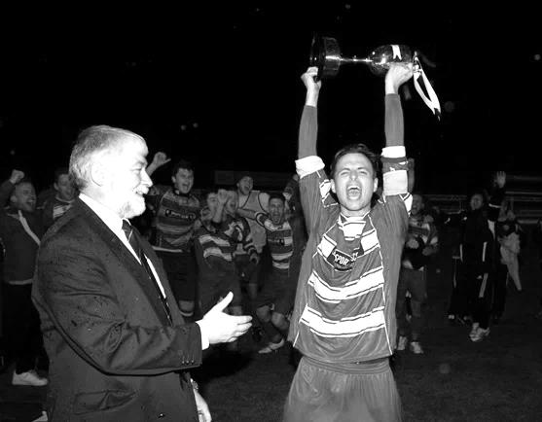
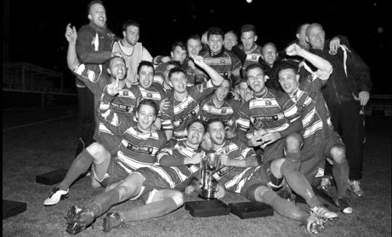
Second Round
Dorking Wanderers | 2-1 | South Park Reserves
Westfield | 1-0 | CB Hounslow United
Bedfont & Feltham | 1-5 | Colliers Wood United
Dorking | 0-3 | Knaphill
Badshot Lea | 2-4 | Spelthorne Sports
Hanworth Villa | 1-2+ | Chertsey Town
Ashford Town (Mx) | 2-1 | Epsom Athletic
Hartley Wintney | 4-2 | Horley Town
Banstead Athletic | 1-1+ | Epsom & Ewell
Epsom & Ewell won 7-6 on penalties
Sheerwater | 3-3+ | Frimley Green
Frimley Green won 8-7 on penalties
Farnham Town | 3-2 | Abbey Rangers
Camberley Town | 4-2 | Eversley & California
AFC Hayes | 0-1 | Banstead Athletic
Redhill | 3-0 | Sutton Common Rovers
Worcester Park | 1-5 | Chessington & Hook United
Cove | 1-6 | Cobham
Third Round
Camberley Town | 12/1 | Spelthorne Sports
Cobham | V | Frimley Green
Redhill | V | Farnham Town
Raynes Park Vale | V | Westfield
Epsom & Ewell | 12/1 | Ashford Town (Mx)
Colliers Wood United | 6-0 | Dorking Wanderers Reserves
Knaphill | V | Chertsey Town
Hartley Wintney | V | Chessington & Hook United

Match report by Sam Brooker
Epsom & Ewell 4-0 Guildford City
Combined Counties League - Premier Division - Saturday 5th December 2015

Guildford blown away in first half as Salts cruise to victory

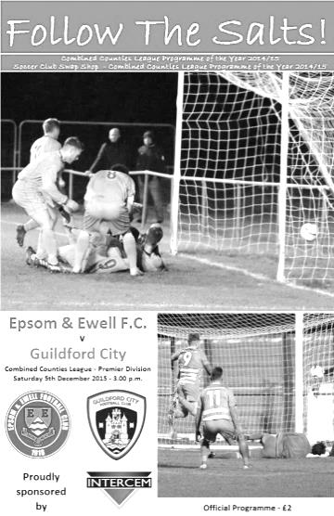
Epsom and Ewell's previous home fixture consisted of a spectacular 5-0 defeat of Hanworth Villa. On Saturday we continued our home form to sink Guildford City 4-0, with an equally tremendous display; despite James Taylor's injury (that he picked up on Saturday 28th) adding to the ever-growing list that consists of key figures including club captain - Sam Currie.

Epsom's strength in depth was tested as Daryl Cooper-Smith was also absent due to suspension, Tom Neale inherited his vacant number 10 shirt and certainly did it justice, adding a goal to his name. Carl Downs had come back into the side's midfield while Michael Eacott returned in goal after having work commitments last Saturday.

The home side began the encounter as they intended to go on, playing with composure and an eagerness to get numbers forward. Initially, the power of Guildford's Connor French, combined with the speed of Adam Nditi, made it extremely difficult for the home side to settle into the game - our attempts were further inhibited by the strong winds that acted as a 12th man for the away side, battling against any attempted clearance from Epsom.

In the opening minutes, Neale displayed his searing pace down the left flank but took an accidental touch with his left foot that disrupted his shot selection at the critical point, sending the effort wide. However, our boys broke the deadlock in the 8th minute. Neale finished off an excellent team goal that was expertly executed: McKay looped a ball towards the back post which was headed across the goal by Kyle Hough before Neale got to the ball first (a sight that became familiar over the course of the match) and applied the finishing touch. In the immediate moments following this, Epsom managed to retain the lead largely from the mistakes of Guildford when attacking, rather than their own defending prowess.

Hough mirrored Neale's effort up front, nearly running clear of the defence that was split by a pinpoint pass from Rhys North in the 15th minute. Unfortunately, the ball got caught up in Hough's feet, rendering him unable to release a shot. Chances then began arising thick and fast, as captain Matt Farrell's acrobatics forced a save from Liam Beach. The speed of the number 10's on both sides was evident early on, North managed to nullify Nditi well, but Neale caused chaos amongst the yellow defence and was cynically brought down in the 17th minute, which left him hobbling back into the box to compete for the resulting free kick.

The Salts second goal came in the 19th minute through Farrell. The eventual goal scorer began the attack, winning the second header in the middle of the park and knocked the ball

forwards to Neale who utilised his speed to worry the defence and draw bodies towards him, leaving Farrell free (inside the box) to tuck Neale's ball into the roof of the net. We showed the reasons for our superior league position as we seemed to dominate all areas of the pitch, building from a stable back four and efficiently progressing up the field of play. This progression usually came from the danger posed on both wings by the tricky Matt Ferdinando on the left and the combination of Tom Neale and Reisse Griffin on the right.

Guildford's first genuine opportunity was squandered in the 33rd minute by a strong save by Eacott that palmed the swerving shot over the bar, this allowed Epsom to demonstrate their uncanny ability to craft defence into attack as we responded with a 35th minute goal, which came about as a result of Griffin's persistence on the right as he glided down the wing before bending a delicious cross into the box that was skilfully volleyed in at full stretch by a sliding Kyle Hough - beyond the reach of Beach in the Guildford goal. Our boys always seemed to have numbers in the box, awaiting the inevitable probing balls from the midfield maestros, unlike Guildford, who often appeared to only have the isolated Nditi as their attacking option.

As the first half drew to a close, we maintained our intensity. and were rewarded in the 43rd minute as a looping free kick was delivered by Ferdinando and headed back across the goal by Craig Hastings (in a similar fashion to the first goal), on this occasion, scored by Hough, allowing the Salts to take a 4-0 lead into the second half.

As the second half commenced, many were keen to make their mark on the game, Matt Tanton for example, began sending balls forward into space for our strikers to run on to, however, on this occasion none resulted in goals. Both sides managed to maintain their shape and discipline for the first 10 minute period of the new half, with free kicks only being conceded within the opposition's half. Tanton dispossessed French as the Guildford man prepared to embark on one of his destructive runs into our defence. As a result, he ended up requiring treatment on his neck.

As the hour mark approached, play began to disintegrate largely due to the windy conditions. For Guildford Nathan Chambers was booked for repeated late tackles. On offensive ventures, we weren't as clinical as we had been in the first half, although we protected our four goal lead fairly comfortably, and our organisation at the back was commendable throughout under the instruction of Eacott and McKay; this formed the spine of the team and allowed the forwards to flourish. Our unbreachable home defence frustrated the away side, as evidenced by Nditi's yellow card for dissent in the 89th minute.

Guildford seemed to produce panicked responses whenever they obtained possession as the clock ticked on and the pressure built, in stark contrast to the confident performance that Epsom were displaying. Credit to both sides for competing until the final whistle, Guildford's Nditi struck the woodwork in the 85th minute from a set piece that left Eacott rooted to the ground and relieved to hear it ricochet off of the bar to safety, Hastings followed suit for our boys with the final kick of the game, but in reality this match was all over by half time and everyone knew it.

Team: Michael Eacott, Rhys North, Matt Tanton, Craig Hastings, Alex McKay, Carl Downs, Reisse Griffin, Matt Farrell (C), Kyle Hough, Tom Neale, Matt Ferdinando.

Subs: Rob Hendry for Hough (53), Steve Rowe for Downs (60)
Beckett Oliver for Grifffin (81)

From behind the goal – not much to see!
Epsom & Ewell p-p Cove
Combined Counties League - Premier Division - Tuesday 8th December 2015

For those who are unaware, we didn’t play Cove last Tuesday evening. The opposition were unable to put a team together and had to default on the fixture.

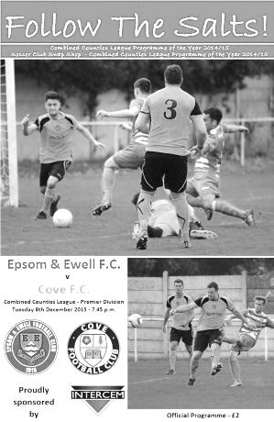
As it stands the match will show as postponed, although we have this week been advised by the League that the game will be rearranged for later in the season.

Whilst frustrating, it is Cove I feel most sorry for, having now been given a three week break by the League, and we hope they will be able to restart their fixtures on 2nd January at home to Spelthorne Sports. If they are unable to do this, they may well have to resign from the league, which would mean we would lose our 7-0 victory there from the table. Not an ideal scenario either way really!

When we know more about the new date we’ll let you all know.

Player Profile – Number 10 – Rob Hendry

Our latest player profile is from another of our new players this season, Rob Hendry.

Age: 25

Position: Striker

Club supported: Charlton Athletic (father Jimmy used to be Physio there)

Favourite Food: Liquid Diet!

Messi or Ronaldo: Ronaldo

Favourite Drink: Beer

Favourite Holiday Destination: Las Vegas

Favourite Ground played at: Stamford Bridge, Chelsea FC

Previous Club: Glyn Old Boys

Describe the Gaffa in three words: Smudge’s – Number – Two

Rob’s Playing Stats: First Team Debut : 08/08/2015

Appearances: 20 - Sub: 3 - Total: 23 - Goals: 8

CCL Premier Division Club Directory
A.F.C. HAYES Telephone: 0208-845-0110 - Ground: Farm Park, Kingshill Avenue, Hayes, Middx. UB4 8DD - Colours: Blue and White Stripes/Blue/Blue

ASHFORD TOWN (Mx) Telephone: 01784-245908 - Ground: The Robert Parker Stadium, Short Lane, Stanwell, Middx. TW19 7BH - Colours: Tangerine & White Stripes/Black/Tangerine

BADSHOT LEA Telephone: 01252-320385 - Ground: Ash United FC, Shawfield Stadium, Youngs Drive, Shawfields Road, Ash, Hampshire. GU12 6RE - Colours: Claret/White/Claret

BEDFONT SPORTS Telephone: 0208-831-9067 - Ground: Bedfont Sports Club, Hatton Road, Bedfont, Middx TW14 8JA - Colours: Red & Black Hoops/Black/Red & Black Hoops

CAMBERLEY TOWN Telephone: 01276-65392 - Ground: Krooner Park, Wilton Road, Camberley, Surrey. GU15 2QW - Colours: Red & White Stripes/Blue/Red

CHERTSEY TOWN Telephone: 01932-561774 - Ground: Alwyns Lane, Chertsey, Surrey. KT16 9DW - Colours: Royal Blue & White Stripes/Royal Blue/Royal Blue

CHESSINGTON & HOOK UNITED Telephone: 01372-602263 - Ground: Chalky Lane, Chessington, Surrey. KT9 2NF - Colours: Blue/Blue/Blue

COLLIERS WOOD UNITED Telephone: 0208-942 8062 - Ground: Wibbandune Sports Ground, Robin Hood Way, Wimbledon. SW20 0AA - Colours: Blue & Black Stripes/Black/Black

COVE Telephone: 01252-543615 - Ground: Oak Farm Fields, 7 Squirrel Lane, Cove, Farnborough, Hampshire. GU14 8PB - Colours: Yellow/Black/Yellow

EPSOM & EWELL Telephone: 01737-553250 - Ground: Chipstead FC, High Road, Chipstead, Surrey. CR5 3SF - Colours: Royal Blue & White Hoops/Royal Blue/Royal Blue & White Hoops

FARNHAM TOWN Telephone: 01252-715305 Ground: Memorial Ground, Babbs Mead, West Street, Farnham, Surrey. GU9 7DY Colours: - Claret & Sky Blue /White/ Claret & Sky Blue

GUILDFORD CITY Telephone: 01483-443322 - Ground: The Spectrum, Parkway, Guildford, Surrey. GU1 1UP - Colours: Red & White Stripes/Black/Black

HANWORTH VILLA Telephone: 0208-831-9391 - Ground: Rectory Meadows, Park Road, off Hounslow Road, Hanworth, Middlesex. TW13 6PN - Colours: Red & White Stripes/Black/Black

HARTLEY WINTNEY Telephone: 01252-843586 - Ground: Memorial Playing Fields, Green Lane, Hartley Wintney, Hants RG27 8DL - Colours: Orange & Black/ Orange /Orange

HORLEY TOWN Telephone: 01293-822000 - Ground: The New Defence, Anderson Way, Court Lodge Road, Horley, Surrey. RH6 8SP - Colours: Claret & Sky Blue/Claret/Claret

KNAPHILL Telephone: 01483-475150 - Ground: Brookwood Country Park, Redding Way, Lower Guildford Road, Knaphill, Surrey. GU21 2AY - Colours: Red/Black/Red

SUTTON COMMON ROVERS Telephone: 01932-866386 - Ground: Sutton United FC, Gander Green Lane, Sutton, Surrey SM1 2EY - Colours: Yellow/Black/Black

RAYNES PARK VALE Telephone: 020-8540-8843 - Ground: Prince Georges Playing Field, Grand Drive, Raynes Park, London. SW20 9NB - Colours: Blue/Blue/Red

REDHILL Telephone: 01737-762129 - Ground: Kiln Brow, Three Arch Road, Redhill, Surrey RH1 5AG - Colours: Red and White Stripes/Black/Red

SPELTHORNE SPORTS Telephone: 01932-961055 - Ground: Spelthorne Sports Club, 296 Staines Road, Ashford Common, Ashford, Middx. TW15 1RY - Colours: Light & Dark Blue/Dark Blue/Light Blue

WESTFIELD Telephone: 01483-771106 - Ground: Woking Park, Kingfield Road, Woking, Surrey. GU22 9BA - Colours: Yellow/Black/Black

WINDSOR Telephone: 01753-860656 - Ground: Stag Meadow, St Leonards Road, Windsor, Berks SL4 3DR - Colours: Red/Red/Red

Club Records - 19th December
Date | Day | Competition |  | Opponents |  | Scorers
19/12/31 | Sat | London League | H | Beckenham | 3-0 | B.Marlow, R.Marlow, B.Williams
19/12/36 | Sat | Friendly | H | Fulham Reserves | 8-2 | B.Randall (3), H.Pullen (2), J.Jones, G.Collins, C.Staples
19/12/53 | Sat | Corinthian League | A | Eastbourne | 0-2
19/12/59 | Sat | Corinthian League | A | Chesham United | 1-3 | P.Wood (pen)
19/12/64 | Sat | Athenian League 1 | A | Eastbourne | 3-4 | B.Mackay (2), T.McGrogan
19/12/70 | Sat | Athenian League 2 | H | Uxbridge | 1-2 | K.Ward
19/12/78 | Tue | Isthmian League 1 | H | Finchley | 4-0 | T.Tuite (2), D.Walker, J.Hunn
19/12/87 | Sat | Isthmian League 2s | H | Ruislip Manor | 1-6 | S.Flack
19/12/92 | Sat | Isthmian League 3 | A | Royston Town | 1-2 | M.Alcindor
19/12/98 | Sat | Isthmian League 3 | A | Tring Town | 1-2 | S.Grant
19/12/00 | Tue | F.A. Vase 3 | H | Marlow | 1-1+ | B.Forey
Historical Decades
Date | Day | Competition |  | Opponents |  | Scorers
90 years ago – Epsom Town F.C.
26/12/25 | Sat | Surrey Senior League | H | Reigate Priory | 8-0 | R.Marlow (4), T.Evans (2), F.Kent, R.Sperring
80 years ago – Epsom F.C.
21/12/35 | Sat | London League | H | Park Royal | 8-1 | H.Pullen (3), J.Jones (2, 1 pen), B.Harris (2), B.Neal
70 years ago – Epsom F.C.
22/12/45 | Sat | Surrey Senior Cup QF | A | Corinthian Casuals | 0-6
60 years ago – Epsom F.C.
17/12/55 | Sat | Corinthian League | A | Edgware Town | 1-1 | D.Hermitage
50 years ago – Epsom & Ewell F.C.
18/12/65 | Sat | Athenian League 2 | H | Eastbourne United | 1-2 | B.Harding
40 years ago – Epsom & Ewell F.C.
20/12/75 | Sat | Athenian League Cup 2 replay | H | Hounslow | 0-2
30 years ago – Epsom & Ewell F.C.
17/12/85 | Tue | Isthmian League Cup 3 | H | Dulwich Hamlet | 3-2+ | R.Kidd (2, 1 pen), P.Kemp
20 years ago – Epsom & Ewell F.C.
16/12/95 | Sat | Isthmian League 3 | A | Northwood | 2-4 | P.Meredith, A.Boxall
10 years ago – Epsom & Ewell F.C.
17/12/05 | Sat | Isthmian League 2 | A | Ware | 0-7

History Corner - 19th December
90 years ago this week we hosted the famous Amateur club Reigate Priory in a Surrey Senior League match. However, any hospitality was left in the West Street boardroom as we crushed them by eight clear goals. Reg Marlow scored four of these while Tommy Evans scored two, Reg Sperring and F.Kent scored the others. At the end of the season we were celebrating our first Surrey Senior League title in our first season at West Street.

80 years ago this week we hosted Park Royal in a League match. However, the Champions for the past four seasons had moved their first team completely to Southall F.C. and all that really remained was a Reserve team. For the first season in our history we were struggling too and were unable to take advantage of the vacancy at the top of the table, but we still won this match 8-1 with Jackie Pullen scoring three of the goals, while Jimmy Jones got two, B.Harris scored another two and Billy Neal got the other one.

79 years ago today Bill Randall scored a hat trick as we defeated Fulham Reserves in a friendly match at West Street. Randall had joined from Dagenham and scored at a healthy rate for us but didn’t stay long.

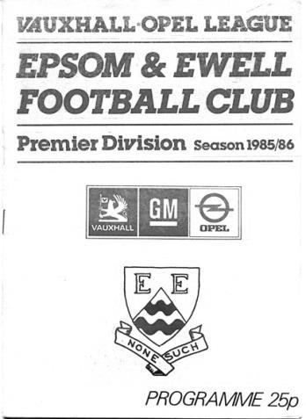
30 years ago this week we hosted Dulwich Hamlet in a League Cup tie, defeating them 3-2 after extra time. We had lost all four matches against them in our brief two season stay in the Isthmian Premier Division and the signs didn’t look good as we went behind in extra time, but we fought back and Ricky Kidd forced home an unlikely winner in the top goal at West Street. I remember it well as it was about the last success we had at that level. We were knocked out by lower division Uxbridge in the Quarter-Final and went down at the end of the season. (see programme right)

28 years ago today we hosted Ruislip Manor in good form. However, the wheels really fell off this day and we subsided 6-1 at home. Our young keeper Terry Victory picked up much of the blame, somewhat harshly, and never played for our club again.

15 years ago today we hosted Marlow in an important Third Round F.A. Vase match. They got a dodgy penalty while we had a blatant one ruled out and we had to settle for a 1-1 draw after extra time, losing 2-1 in the replay two days later. Marlow would go on to reach the last 16 in the competition, while for us it would be ten years before we would get that far in the competition again. This was the last time we played on this day.

10 years ago this week we visited high flying Ware in a League match and it was a disaster. Midfielder Chris Read was sent off after just 13 minutes and we were crushed 7-0. It was our sixth consecutive defeat and following the game, long serving defender Nigel Bennett announced his retirement after 630 games for us. Clearly there were problems and Manager Paul Pritchard would eventually be replaced in the August of 2006 as results remained poor.

Combined Counties League Premier Division Opponents
All-time Records
incl Saturday 12th December | P | W | D | L | F | A | PPG | GD | Best  Win | Worst  Loss
Spelthorne Sports* | 4 | 3 | 1 | 0 | 13 | 5 | 2.50 | +8 | 6-2 | -
Sutton Common Rovers | 9 | 7 | 1 | 1 | 24 | 11 | 2.44 | +13 | 4-0 | 1-4
Horley Town | 26 | 19 | 4 | 3 | 57 | 24 | 2.35 | +33 | 6-0 | 1-3
Westfield | 17 | 11 | 3 | 3 | 39 | 27 | 2.12 | +12 | 6-1 | 0-4
Colliers Wood United | 21 | 14 | 2 | 5 | 45 | 28 | 2.10 | +14 | 4-0 | 0-3
Knaphill | 5 | 3 | 1 | 1 | 10 | 6 | 2.00 | +4 | 4-1 | 1-2
Bedfont Sports | 8 | 4 | 2 | 2 | 12 | 10 | 1.75 | +2 | 3-0 | 0-4
Guildford City | 15 | 8 | 1 | 6 | 27 | 21 | 1.67 | +2 | 4-0 | 1-5
Farnham Town | 12 | 6 | 2 | 4 | 21 | 21 | 1.67 | 0 | 3-1 | 1-4
Raynes Park Vale | 25 | 12 | 5 | 8 | 54 | 36 | 1.64 | +18 | 6-1 | 0-2
Hanworth Villa | 13 | 6 | 3 | 4 | 31 | 22 | 1.62 | +9 | 5-0 | 1-4
Hartley Wintney | 9 | 4 | 3 | 2 | 25 | 16 | 1.60 | +9 | 5-0 | 2-4
Camberley Town* | 86 | 38 | 20 | 27 | 155 | 119 | 1.56 | +36 | 9-1 | 0-4
Chessington & Hook | 27 | 11 | 9 | 7 | 52 | 41 | 1.56 | +11 | 6-0 | 1-3
Cove | 33 | 14 | 9 | 10 | 74 | 55 | 1.55 | +19 | 7-0 | 1-6
Windsor | 46 | 18 | 12 | 16 | 86 | 86 | 1.43 | 0 | 4-0 | 0-6
Badshot Lea | 16 | 6 | 3 | 7 | 27 | 32 | 1.31 | -5 | 3-0 | 0-4
Redhill | 32 | 13 | 2 | 17 | 60 | 69 | 1.28 | -9 | 7-2 | 2-8
Chertsey Town | 46 | 16 | 5 | 25 | 65 | 83 | 1.15 | -18 | 3-0 | 0-7
Ashford Town (Mx) | 16 | 4 | 2 | 10 | 22 | 41 | 0.88 | -19 | 3-0 | 0-5
AFC Hayes | 7 | 1 | 2 | 4 | 9 | 15 | 0.71 | -6 | 3-1 | 0-3
Grand Total | 476 | 220 | 91 | 164 | 896 | 772 | 1.58 | 124 | - | -
* includes one abandoned match v Camberley and one loss on penalties v Spelthorne

Latest Results Grid
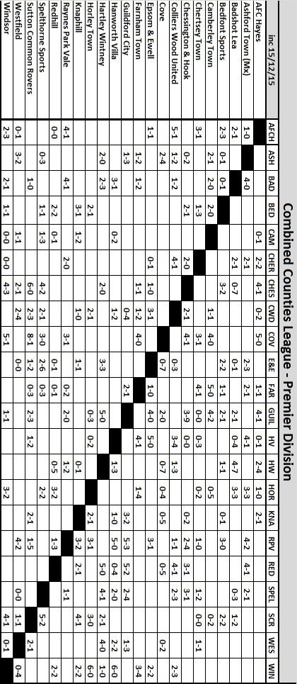

Centre page for results

Centre page for results



Sutton Common Rovers F.C. – History
Chairman and Life President Alan Salmon founded SCR F.C in 1978, when the club began life as INRAD FC, based in Carshalton. The club entered a new era when Alan moved to Sutton and arranged sponsorship with his new neighbour, CENTRE 21 FC was born. This era saw the club running one Saturday side, three Sunday sides and three Youth sides. Centre 21's sponsorship continued until the club's youth players were no longer under 21 years old.


The club again sought a new identity; SUTTON COMMON ROAD FC was formed and subsequently abbreviated to SCR FC. Since then the club has had five major sponsors whose names have been incorporated into the clubs affiliated name: SCR PLOUGH (twice), SCR GRAPES, next the club's longest sponsor SCR LITTEN TREE (7 years) & finally SCR Kingfisher, Ewell with whom we started our venture in Saturday football in 2004/05.

It was at this point that the club took the decision to revert back to using the SCR name alone, feeling that as we strive for continued promotion we needed to disassociate ourselves with the whole ‘pub team’ image. The club however did take sponsorship form the Fox & Hounds, Carshalton for the Sat first team in 2006/07, but the decision was made that the pub name would not be incorporated into our own, for the above reason…

The club entered yet another new era this season, with the introduction of a third Saturday side (Messers Alex Avis & Tony Williams) and the 1’s moving to the Middlesex County FL (and a name change SUTTON COMMON ROVERS) in the pursuit of combined Counties football, having made an unsuccessful application from the Surrey South Eastern Combination at the end of season 2006/07 having finished joint top (3rd on goal difference… -1 goal)

A third place finish in the Middlesex County League Premier division in 07/08 meant that our promotion to the CCL was not assured but months of hard work & determination from the management team SCR eventually secured a place for the clubs 1st time in their 30 year history at the league AGM in June 2008 and the reserves joined the CCL reserve division under the guidance of Alex Avis & Justin Salmon.

Season 08/09 saw the latest name change of the club, the inclusion of “MOLE VALLEY” to form our current name, MOLE VALLEY SCR FC reflecting the area in which we play since migrating from the London Borough of Sutton. Season 09/10 saw the club reach a Surrey Cup final, narrowly being defeated by Sutton United after a 1-1 extra time score line on penalties and in the same season compete in the FA Vase for the first time in our relatively short history.

We finished Champions of Division One (playing out of Cobham FC after we lost our ground two weeks before the start of the season) at the second time of asking, narrowly pipping Worcester Park to the post in a fine run which saw us finish 3 points clear on the final match of the season, assuming as we believed, we were awarded the points from the postponed Coulsdon match who unfortunately were unable to field a side for our scheduled league game some weeks earlier.

The following season saw the club play at our highest level to date, and make our FA Cup debut, although this lasted just one game, and ended in a 5-0 defeat against Chertsey Town.

The club managed two seasons in the Premier Division, before being relegated back to Division 1, following a start to the season that saw 12 straight league defeats.

The 2012/13 season started with a rebuilt side and expectations of consolidation, however a 20 game unbeaten run propelled us into runners up spot, and a much coveted promotion back to the Premier Division. 2013/14 started brightly, but went to the last game, and a point saw survival. It was the same last season, and although we lost (to Guildford City), we still managed to survive.

For the 2015/16 season, there has been a change of name to Sutton Common Rovers, and after much hard work by The Salmons, a return to Sutton (we thank Cobham for all they did for us over the time we were with them), but we now return home, and a groundshare with Sutton United.

Surrey Senior Cup
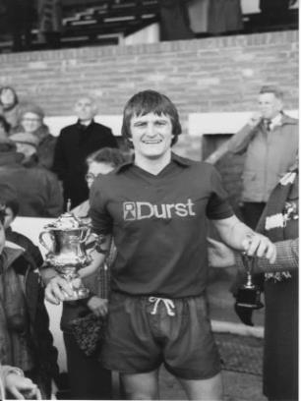
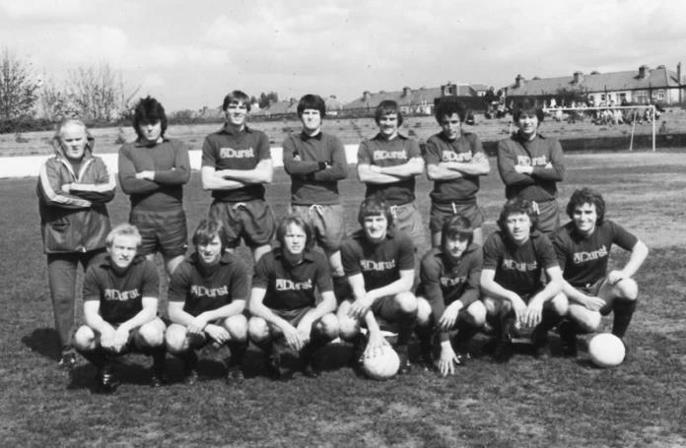
Second Round
Knaphill | 4-3 | Ashford Town (Mx)
Chipstead | 4-1 | Chessington & Hook United
Colliers Wood United | 1-3 | Whyteleafe
Corinthian Casuals | 1-1 | Egham Town
Corinthian Casuals won 4-2 on penalties
Croydon | 3-3 | Farnham Town
Farnham Town won 3-2 on penalties
Godalming Town | 1-0 | Guildford City
Horley Town | 2-2 | Badshot Lea
Badshot Lea won 4-3 on penalties
Leatherhead | 3-0 | Carshalton Athletic
Merstham | 3-0 | South Park
Met Police | 3-2 | Dorking Wanderers
Molesey | 2-1 | Raynes Park Vale
Redhill | 0-3 | Tooting & Mitcham United
Sutton United | 3-0 | Walton & Hersham
Walton Casuals | 1-1 | Kingstonian
Kingstonian won 9-8 on penalties
Westfield | 2-0 | Chertsey Town
Woking | 10-0 | Sutton Common Rovers
Third Round
Godalming Town | V | Tooting & Mitcham United
Whyteleafe | V | Farnham Town
Leatherhead | V | Kingstonian
Badshot Lea | V | Merstham
Westfield | V | Woking
Met Police | V | Molesey
Knaphill | V | Chipstead
Corinthian Casuals | V | Sutton United

From behind the goal
Badshot Lea 0-1 Epsom & Ewell
Combined Counties League - Premier Division - Saturday 5th December 2015

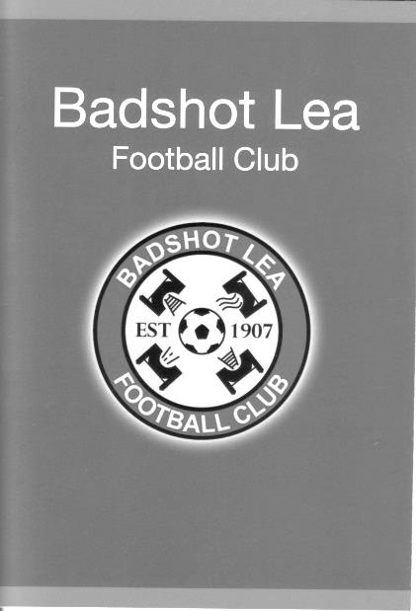
Ferdi makes the difference

The Ash United ground that Badshot Lea temporarily use has seen better days. It is in need of some repairs and from a spectators point of view there are nicer grounds to visit. However, for Matt Ferdinando, it could be his favourite venue, having won two penalties here in a superb performance exactly one year ago this weekend, while this time he was excellent and got on the scoresheet, with his 9th minute free kick being worth the admission money itself and deserving of winning any match.

In terms of personnel Matt Tanton and Daryl Cooper-Smith were suspended, while James Taylor and Sam Currie remained injured. In place of Tanton, both Steve Rowe and Jamie Hatfield had been signed up as cover, but Hatfield was away and Rowe picked up a nasty injury at training on Thursday that I am advised may well end his season. As a result Alex McKay drew the short straw and found himself out on the left, although it was good to see Dan Dean returning for his first match after a few weeks out with a groin injury and he slotted in alongside Craig Hastings at the back.

Our opponents started well. They had the benefit of quite a strong wind in the first half and had recently beaten both Hartley Wintney and Bedfont Sports on their own patches so were going to be no pushovers. However, Ferdinando beat two men to set Hough up for a strike over the bar with just three minutes on the clock, before a foul on Hough twenty yards out gave us the opportunity to take the lead, which our right winger duly did with a scorching free kick into the top corner of the net, giving Pat Kinsella in the home goal no chance whatsoever.

We fashioned occasional chances as the half progressed. Tom Neale scuffed a shot, although it came to him off a deflection from a shot from Reisse Griffin, playing out on the left this day, while Carl Downs struck a shot just over the bar after Dean had won the ball from a corner and laid the ball back to him. In all honesty though, we were not at our fluent best and we had a bit of a scramble in our own area after 26

minutes which could have gone anywhere but looped up to the waiting Michael Eacott while a couple of minutes later they had a bit of room on the right wing but the powerful low shot was straight at the well-positioned Eacott from 15 yards. They got closer still in the 38th minute when a shot got past big Mike but was cleared off the line by Hastings. Fortunately, Ferdinando was causing trouble on the right wing and combined well with Matt Farrell, retrieved the return pass and cut in on goal but his shot from a narrow angle was straight at Kinsella with others better positioned waiting frustratedly in the box.

There were some erratic decisions flying about too, and although Ferdinando was on the receiving end of the first couple, neither of which were deemed a foul by the way, the home side finally started to make regular appearances into the book with two in the first half and a third for a nasty foul on Griffin, although Eacott also found his way into the book for shouting at his own defenders following the award of a free kick against us in the corner! The home side probably had the rougher end of the decisions over the ninety minutes and this had a result of breaking up the game a bit, although we had a scare when a close range shot was blocked by Downs and then the ball pinged around in our area for what seemed like ages before we broke and nearly scored on the counter attack when Neale got away on the left but just overran the ball in front of the oncoming keeper.

Rob Hendry came on for Hough who was still struggling with the knee injury he picked up at Ashford in October and we looked more threatening as a result. Our sub nearly scored after cutting in on the right and unleashing a fine left footed strike that was tipped away by Kinsella but our chances were becoming fewer as the home side pushed us back in search of a point. However, for their possession there wasn't much in the way of real threat and both Ferdinando and Hendry had other efforts dragged wide of the target as we looked the more dangerous when going forward.

As we reached the fifth minute of injury time Hendry got through again as we hit them on the counter attack but his low shot was half saved, although the ball would have had enough momentum to dribble over the line had it not been cleared by a covering defender. A second goal would have been harsh on the home side who contributed plenty to this match and were worthy of a point. Ultimately, we had a cutting edge whilst they didn't, and coupled with a solid defence right now, our boys are looking very good right now, even when we are not looking good, if you know what I mean!

Team: Michael Eacott, Rhys North, Alex McKay, Dan Dean,
Craig Hastings, Carl Downs, Reisse Griffin, Matt Farrell (c),
Kyle Hough, Tom Neale, Matt Ferdinando

Subs: Rob Hendry for Hough (69), Beckett Oliver for Grifffin (82)

Every Opponent A-Z
Over the years we have played many, many different opponents. Exactly how many is a difficult question, as it all depends on your definition. Are Camberley & Yorktown different to Camberley Town, or are Epsom Town different to Epsom F.C. or Epsom & Ewell F.C.?

In my analysis I have classed them as the same team, and will work through them all from A to Z. Some we have played many times, whilst others we have met just once or twice. Enjoy!


Redhill: Played 32 - W13 D2 L17 - F60 A69 - PPG - 1.28 - Below Average

We have been playing Redhill for many, many years, so it is nice to see us back in the same League again after a gap of nearly three decades.

A number of these matches have been important ones and our first meeting was in our first ever senior status season of 1924/25 in the Amateur Cup. We were a new Surrey Senior League team while they were an established Athenian League outfit, so it was a difficult tie to begin with. When you throw in the fact that we had to concede home advantage (as the Horton Sports Ground could not be enclosed and we couldn’t take a gate) it got tougher still and so it proved when on 15th November 1924 we were heavily beaten 5-0 on our first visit to the Memorial Ground, although we kept it competitive in the first half, only trailing 1-0 at the break.

As we moved up the leagues and into the London League we met on two occasions in the East Surrey Hospital Cup and the results were contrasting to say the least. On 12th December 1925 we were crushed 8-2 at our new West Street home, with only two late consolations making the score look slightly less worrying. However on 10th March 1928 we returned the favour, again at home, winning 7-2. We led 5-0 at the half and Freddie Behn score a hat trick as we handed the Lobsters their first ever defeat in the competition.

A narrow Surrey Charity Shield defeat in November 1928 was next before arguably the most important meeting between the clubs when we contested the 1929 Surrey Senior Cup Final at Guildford City’s old ground in Josephs Road. We led at half time, but a harsh penalty award for handball and another goal moments later turned the game around and it was 3-1 by the time we scored again, narrowly missing out in front of 4,600 spectators. We would have to wait 52 further years to lift the trophy.

When considering that we weren’t in the same league we drew each other a lot in cup competitions, contesting nine Amateur Cup ties between the years of 1929 and 1938! I shall go into more detail on these in our next issue when we meet Redhill, but results mostly went well. A massive result for us occurred on 21st November 1931 when we defeated them for the first time on their own ground in the final qualifying round of the Amateur Cup, drawing Ipswich Town at Portman Road in the last 64; a match we also would go on to win.

This started a good run for us as we progressed at their expense in the next two Amateur Cup and the next two F.A. Cup ties. Another of these was again in the Final Qualifying Round of the Amateur Cup where we progressed in a November 1934 replay to face Wimbledon in our third and final visit to the last 64 of the competition.

The next season 1935/36 we were not good by the standard we had set and would finish just 10th out of 13 in the London League. Redhill knocked us out of the Amateur Cup this time and repeated the dose every year for the next three years! Even after the war they were at it again, knocking us out of the Amateur Cup 5-0 in 1946/47, making it five defeats in six competitions before we

mercifully started to avoid them in the competition, largely because they earned an exemption and were weren’t good enough to still be in the competition by the time they entered it!

In 1955/56 we managed to reach the final qualifying round of the Amateur Cup once again, but guess what? They were waiting for us once again and edged us out 2-1 at the Memorial Ground, despite a second half goal from Dave Hermitage.

We didn’t meet for a while after that, but even by the time of our next meeting, in our most successful season of 1974/75 they still beat us. We had won eight straight League matches and only conceded once in that time, yet we still lost 3-0 there in the F.A. Cup on 14th September 1974.

However, the pendulum swung again and Redhill haven’t beaten us since that day. We have met six times since then and our next meetings were as members of the Athenian League Division One after our rise up the divisions and we drew 2-2 there exactly two years to the day of our Cup defeat, while three months later we returned and won 5-0 in the Surrey Senior Cup on our last ever visit to the Memorial Ground. It was surprising bearing this result in mind, that just three weeks later we were only able to win 1-0 at home in the return League match on New Year’s Day 1977!

By the time of our next meeting, both of our famous grounds were no longer in existence, although if you were to visit the park where Redhill’s ground used to be, you can find some small reminders of where the main stand used to be situated, if you look closely enough!

They left their site in 1983, decamping to Kiln Brow and we of course departed West Street ten years later, so by the time of our Surrey Senior Cup tie in 2001 we were hosting at Merland Rise, where goals from Simon Huckle (2) and Joel Rogers ensured a comfortable 3-0 win and we repeated the scoreline in the same competition at the same venue in 2009.

This brings us right up to date and the 11th August of this year when we met for the first time at Kiln Brow in our first League meeting since 1977 where a second half strike from Kyle Hough was enough to clinch the points.

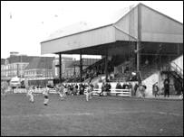
Redhill have been very unlucky over the years. They never did reach the Isthmian League in the old days, then just as they won the Athenian League in 1983/84 they lost their ground and missed out on automatic promotion to the Isthmian League for that reason. This season after many spent in the Sussex League, they found themselves reallocated here after a couple of seasons at Ryman League level but have struggled and there is every possibility that they could go down to Step Six. That would be a disaster for this famous old club and I hope they stay up, although they can wait until after our return meeting in January before starting to pick up points!

Left: The Memorial Ground stand as it looked in its later years

Player Sponsorship
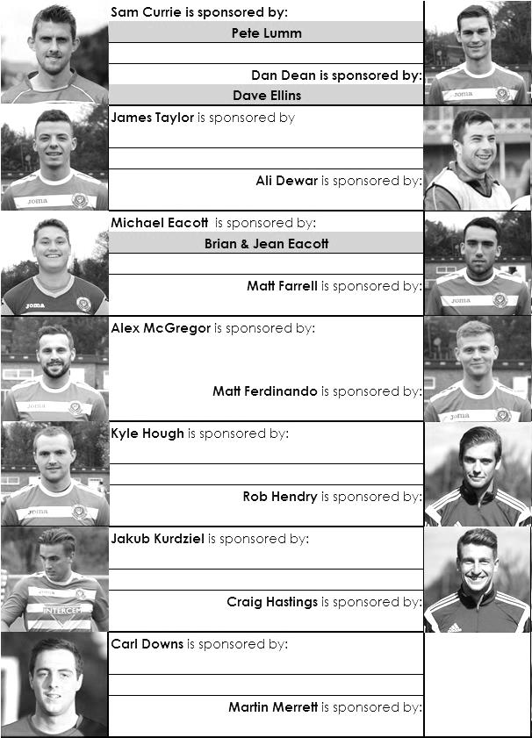

Here is the current list for the 2015/16 season showing all of our players and Management that are currently available for sponsorship this season.

Sponsorship costs just £40 and it is easy to do. Just select a player who has not been previously sponsored and let a Committee Member know that you would like to sponsor them. Beware though. Until we have received the money it is possible for someone to jump in front of you, so don’t delay, sponsor today!

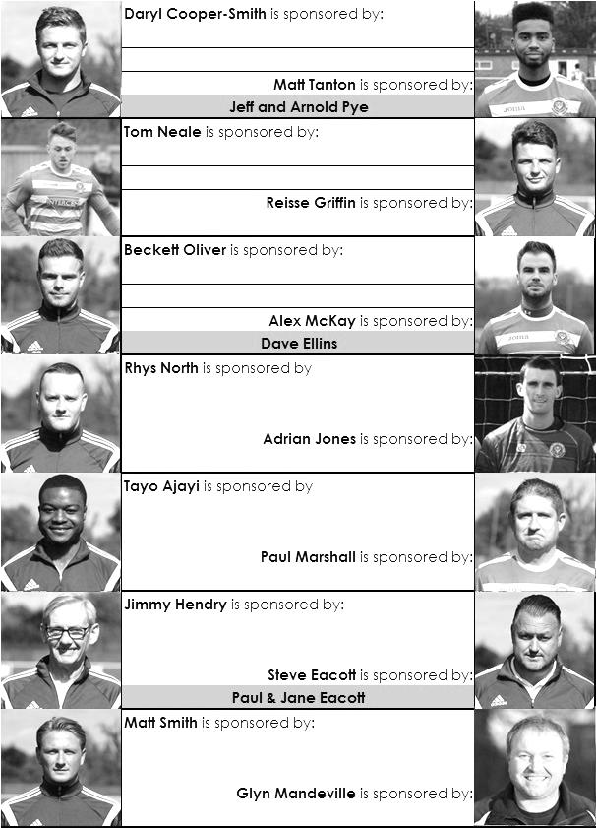

F.A. Vase
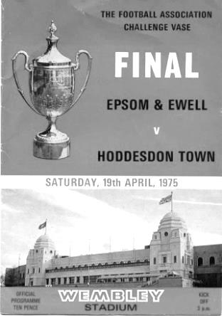
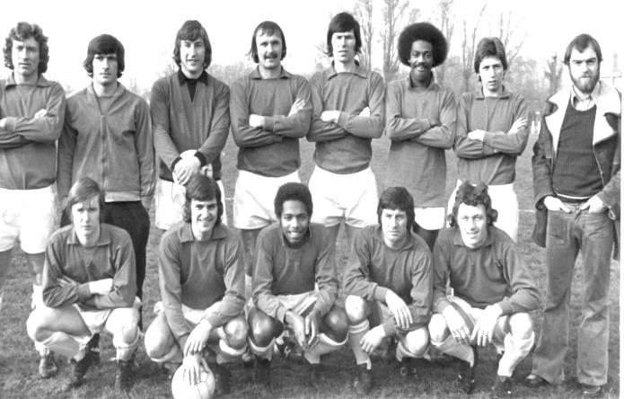
Third Round – Original date for fixtures – 12th December
Marske United | 17/12 | Team Northumbria
Sunderland RCA | 4-0 | Tadcaster Albion
Newton Aycliffe | 22/12 | Atherton Collieries
South Shields | 22/12 | Morpeth Town
North Shields | 1-1+ r22/12 | Runcorn Town
Dunston UTS | 22/12 | Seaham Red Star
Alsager Town | 0-2 | AFC Wulfrunians
St Andrews | 1-5 | Leicester Nirvana
Handsworth Parramore | 1-2 | Cleethorpes Town
Pinxton | 17/12 | Nuneaton Griff
Walsall Wood | 0-3 | Alvechurch
Uttoxeter Town | 3-4 | Coleshill Town
Hereford | 2-0 | Brocton
Saffron Walden Town | 2-3 | Berkhamsted
FC Broxbourne Borough | 23/12 | Bowers & Pitsea
Hullbridge Sports | 2-0 | Stanway Rovers
AFC Dunstable | 4-0 | Basildon United
Edgware Town | 0-3 | Ipswich Wanderers
Yaxley | 3-4+ | Sleaford Town
Hertford Town | 0-2 | FC Romania
Colliers Wood United | 1-3 | Hartley Wintney
Thame United | 1-2 | Kidlington
Ascot United | 0-0+ r1-4 | Camberley Town
Lordswood | 1-5 | Ashford United
Eastbourne Town | 2-3 | Sutton Common Rovers
Tadley Calleva | 2-2+ | Newport (IW)
Canterbury City | 1-3 | Knaphill
Moneyfields | 0-0+ r22/12 | Brimscombe & Thrupp
Buckland Athletic | 1-2 | Bradford Town
Highworth Town | 1-5 | Salisbury
Welton Rovers | 22/12 | Bodmin Town
Bristol Manor Farm | 7-1 | Hengrove Athletic

F.A. Vase
Fourth Round – 9th January
Cleethorpes Town | V | Alvechurch
Northern Counties East – 7th |  | Midland – 2nd
Hereford | V | Leicester Nirvana
Midland – 1st |  | United Counties – 1st
South Shields / Morpeth Town | V | North Shields / Runcorn Town
Coleshill Town | V | Dunston UTS / Seaham RS
Midland – 13th
AFC Wulfrunians | V | Pinxton / Nuneaton Griff
Midland – 7th
Sunderland RCA | V | Sleaford Town
Northern – 8th |  | United Counties – 11th
Newton Aycliffe / Atherton | V | Marske / Team Northumbria
FC Broxbourne Borough /  Bowers & Pitsea | V | Sutton Common Rovers
 |  | Combined Counties – 14th
Kidlington | V | Knaphill
Hellenic – 2nd |  | Combined Counties – 11th
Tadley Calleva / Newport IOW | V | Ashford United
 |  | Southern Counties East – 3rd
Moneyfields /  Brimscombe & Thrupp | V | Bristol Manor Farm
 |  | Western League – 1st
FC Romania | V | Camberley Town
Essex Senior – 4th |  | Combined Counties – 4th
AFC Dunstable | V | Salisbury
South Midlands – 2nd |  | Wessex – 2nd
Berkhamsted | V | Hullbridge Sports
South Midlands – 4th |  | Essex Senior – 10th
Hartley Wintney | V | Bradford Town
Combined Counties – 1st |  | Western League – 8th
Welton Rovers / Bodmin Town | V | Ipswich Wanderers
 |  | Eastern Counties – 12th

Match and Ball Sponsorships – 2015/16
Opponent | Date | Match and Match Ball Sponsor
Hoddesdon Town | 18/07/15 | Geoff Dyke
Windsor | 08/08/15 | Club President - Stella Lamont
Erith & Belvedere (FAC) | 16/08/15 | Committee Member - Mike Lovett
Raynes Park Vale | 31/08/15 | EEFC Management Committee
Colliers Wood United | 08/09/15 | Bookham Building Shop – www.buildingshop.co.uk
AFC Hayes | 19/09/15 | John Bonner
Farnham Town | 26/09/15 | Ezara and Inaya Beddoe – our youngest supporters!
Chertsey Town | 17/10/15 | Club Media Officer – Richard Lambert
Dorking Wanderers (SSC) | 20/10/15 | Tony Ferdinando
Chessington & Hook United | 07/11/15 | Paul Merritt
Hanworth Villa | 21/11/15 | Maggie Beddoe
Guildford City | 05/12/15 | Pete Lumm
Sutton Common Rovers | 19/12/15 | Marvin Hough
Redhill | 02/01/16 | David Lawton
Ashford Town (Mx) (LC) | 12/01/16
Spelthorne Sports | 16/01/16
Hartley Wintney | 30/01/16
Bedfont Sports | 13/02/16
Horley Town | 27/02/16
Knaphill | 12/03/16
Westfield | 26/03/16
Badshot Lea | 09/04/16
Camberley Town | 16/04/16
Ashford Town (Mx) | 30/04/16
Cove | tba
For League, League Cup and Surrey Senior Cup Matches:
Match sponsorship - £40.00 Match ball sponsorship - £25.00. Combined £55.00.
For F.A. Cup and F.A. Vase matches:
Match sponsorship - £50.00 Match ball sponsorship - £30.00. Combined £65.00.

Sponsorship includes: (x2 for match, x3 for match and ball)

Admission, programmes, hospitality and advertising and mascot for the day (if required).
If you are interested, just speak to a Committee Member, or drop me an email at: richard.c.lambert@gmail.com


We also thank our Kit Sponsors INTERCEM

Salts Super Six Predictor
The Salts Super Six Predictor Competition is live again and the tickets are on sale at today’s game to the left of the gate. We recently had our second winner when Maggie Beddoe selected all six results correctly but the jackpot is already beginning to rise.

The competition is easy to play! To win, you simply need to predict the results of the six matches correctly from the three options, fill in the form and make sure it is back with our sellers before the deadline on the ticket.

If you are a club regular, you just need to place your name on the sheet, although if you aren’t, then we’ll need a contact number from you too. We will announce any winners on the website within three working days, so don’t worry we won’t miss you!
The jackpot is now at £117 and who knows how high it could go this time!

Please note that if there is more than one winner, the prize pot would be shared between the winners. All you need to do now is have a go, as many times as you like!

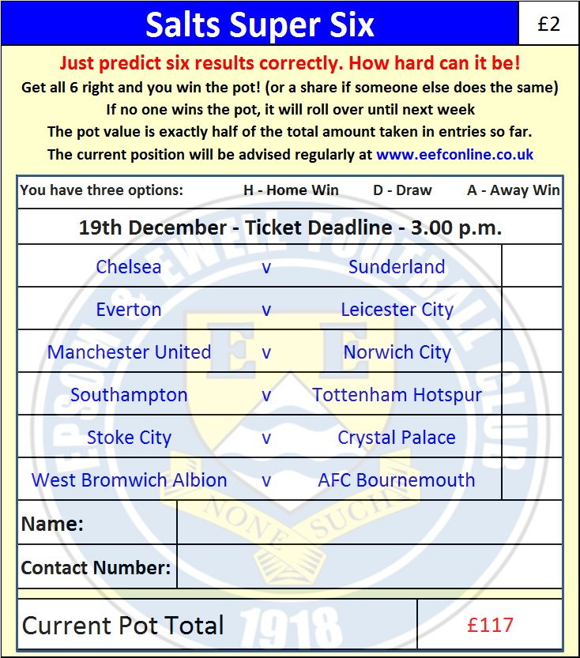

Good luck!

Combined Counties League – Premier Division
Saturday, 19th December 2015 - Kick-off 3.00 p.m.
Epsom and Ewell  (Royal Blue & White hoops) | V |  | Sutton Common Rovers  (All Purple)
Squad | NUMBERS |  | Squad
Michael Eacott |  |  | Leigh Bowden
Rhys North |  |  | Nemo Adams
Matt Tanton |  |  | Hamilton Antonio
Craig Hastings |  |  | Sam Blowers
Alex McKay |  |  | Aaron Bogle
Carl Downs |  |  | Kobe Botwe
Reisse Griffin |  |  | David Burton
© Matt Farrell |  |  | Anson Cousins
Kyle Hough |  |  | Francois Gabbidon
Tom Neale |  |  | Liam Holden ©
Matt Ferdinando |  |  | Richard Monan
James Taylor |  |  | Arnold Okiror
Beckett Oliver |  |  | Harry Smart
Rob Hendry |  |  | Richie Smith
Dan Dean |  |  | Todd Sullivan
Alex McGregor |  |  | Andrew White
Adrian Jones |  |  | Kieran Wright
Sam Currie
Savvas ‘Agi’ Panayiotou
Tayo Ajayi
Jamie Hatfield
Glyn Mandeville | MANAGER |  | Darren Salmon
Matt Smith | ASSISTANT
Steve Eacott / Alex McKay / Jimmy Hendry | COACHES / PHYSIO |  | Ken Bremner / Gary Brigden / Geoff Moxey / Brent Wallage
REFEREE: M.Smith
ASSISTANTS: I.Hempel (Chessington), K.Corrick (Oxted)
Today’s Match and Match Ball are sponsored by
Marvin Hough, father of our long-serving striker Kyle

OUR NEXT VISITORS TO HIGH ROAD ARE:
Redhill
Saturday 2nd January 2016 - Kick-off 3.00 p.m.
Combined Counties League – Premier Division

